**MySQL Workbench Import**

**To import a database using MySQL Workbench**

1. Download files from Webcourses in directory Files🡪MySQL🡪Database backups
   1. sakila.sql
   2. world.sql
2. Launch MySQL Workbench



1. Click on the Local instance MySQL icon

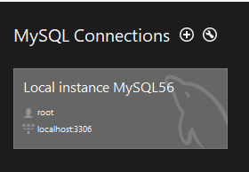

1. Enter the database password

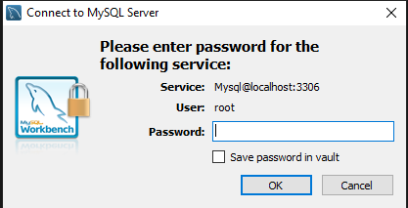

1. Click on the Administration tab

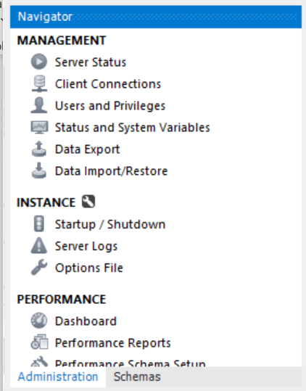

1. Click on Data Import/Restore



1. On the Data Import UI do the following
   1. Select Import from Self-Contained File
   2. Click on the ellipsis to select the directory where the .sql files are saved
   3. Click the New button

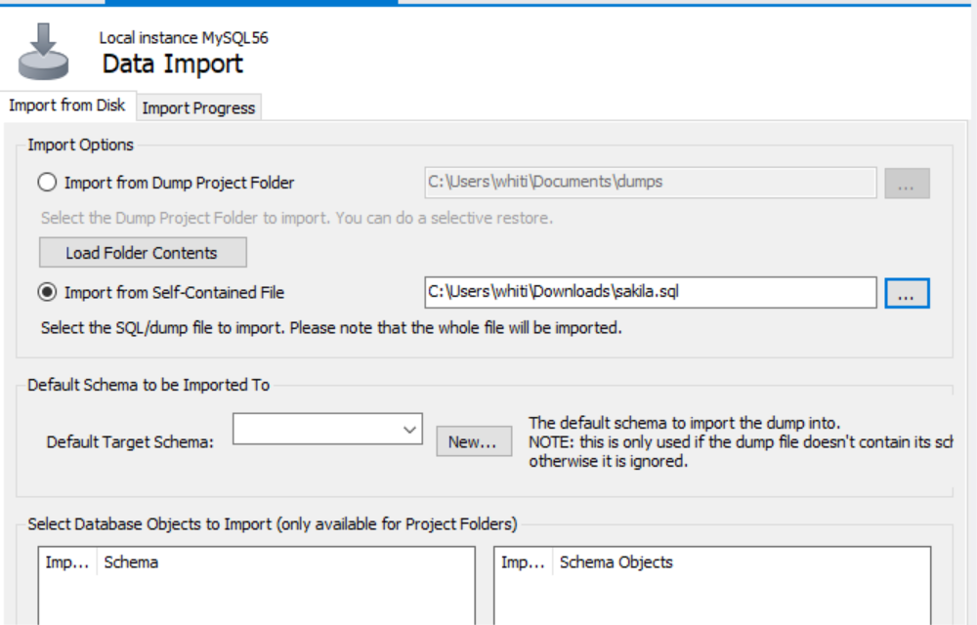

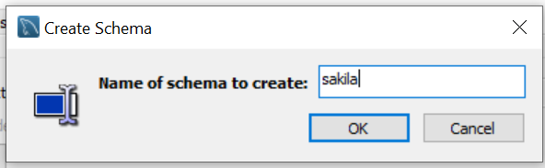

* 1. Enter the name of the database (i.e. sakila or world)
  2. Click the OK button

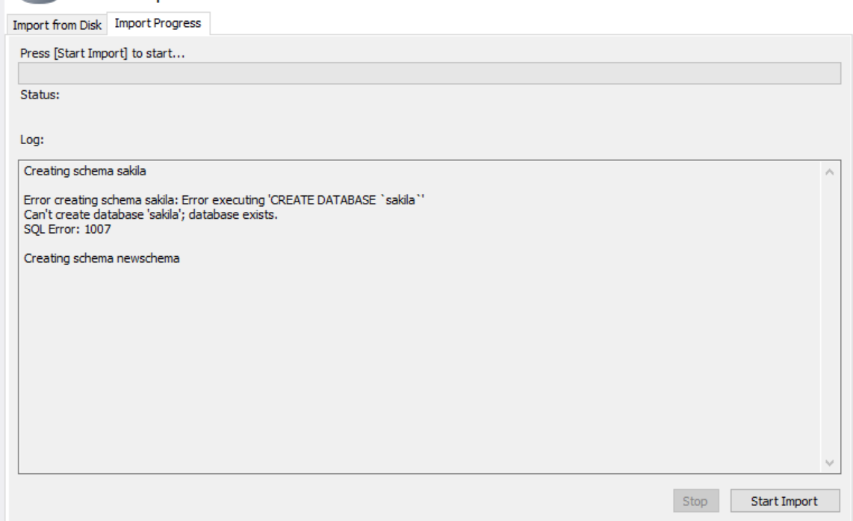

* 1. Click on the Import Progress tab
  2. Click the Start Import button

